# Assignments-1 on gdb

1. Consider the program in folder assign1
2. Compile it so that it compiles with debugging symbols [using proper option]

ans : gcc a.c b.c –g –o out –I./

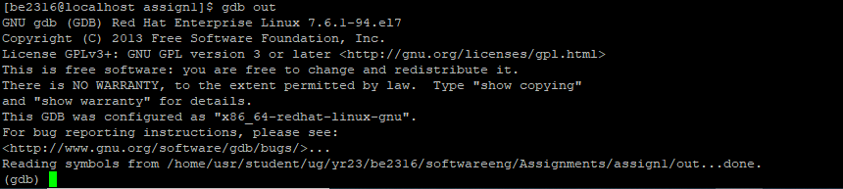

1. Put breakpoint to function f1.

ans:break f1



1. Put breakpoint to line 10 of b.c

break b.c:10



1. Run the program until it finishes. Which commands are you using to take it to completion?
2. How many times breakpoint “1” is hit in one run of the program ?

ans:8 times



1. How many times breakpoint “2” is hit in one run of the program?

ans:4 times

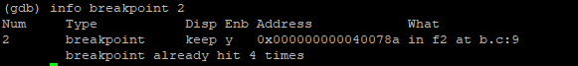

1. How you can see details about a breakpoint ?

ans:info breakpoint<breakpoint number>

1. How you can see details about all breakpoints ?

ans:info breakpoints

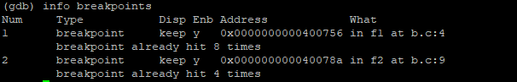

1. What is value of variable x in f1 when breakpoint “1” is hit for 3rd time ? How you can examine it ?

ans:33,ignore 1 2,run, continue, print x

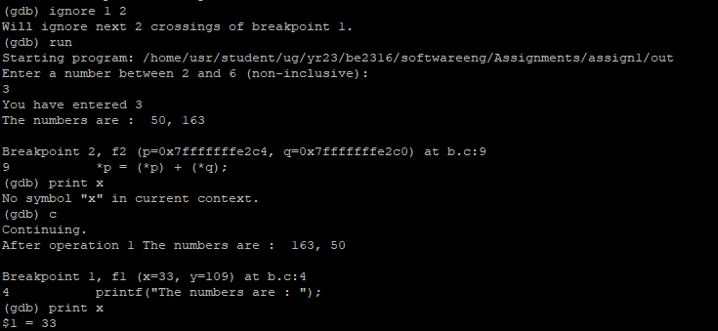

1. Rerun the program .put a breakpoint at function f0. list 5 lines where it has stopped with breakpoint 3 for first time.

sol

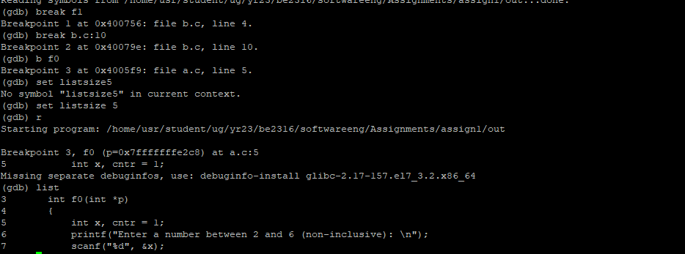

Explore : Complete this rerun. Now see what is the change in details of breakpoint s by using command used in “h”

ans:An extra breakpoint is added rest remains the same

